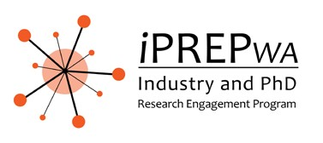

iPREP Biodesign Round 3 2021
18th October – 3rd December (7 weeks)

ITEM | DATE
Student applications & Industry EOIs open | 9th August
Student applications & Industry EOIs close | 6th September
University deadline to check student eligibility | 8th September
Industry partners to review student applications | 8th September
Students notified if shortlisted to 1st Stage Induction | 15th September
1st Stage Induction | 21st September
Industry Partners deadline to select final team | 24th September
Students notified if shortlisted to attend 2nd Stage Induction and of their allocated team | 6th October
Industry partner to meet with team to provide project scope/background reading/allocate tasks/induction/HR | 7th October -8th October
2nd Stage Induction | 11th October
Placement dates (7 weeks) | 18th October – 3rd December
Final presentation event | 10th December
Student deadline to submit of final evaluation report | 10th December

